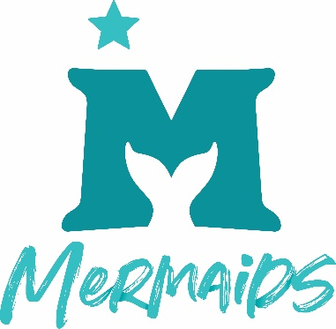

What is Parental Responsibility?

You may have seen the term Parental Responsibility on the Deed Poll templates without understanding what it means and this resource is here to help!

Parental responsibility, or ‘PR’ is a legal term that is defined as, “all the rights, duties, powers and responsibilities and authority which by law a parent of a child has in relation to the child and his property.”

Many parents have ‘PR’ without knowing that they do and some think they have it when they do not.

To find out your own status, we suggest you have a look at the Government’s website.

Should you need further guidance, you can contact a family solicitor. Should you need help with signposting to a family solicitor, please reach out to legal@mermaidsuk.org.uk

